Experiment 4: Data Flow Diagram (DFD)
1. Description of the Diagram
A Data Flow Diagram (DFD) is a graphical representation of how data moves through an information system. It shows external entities, processes, data stores, and the flow of data between them. DFDs are used in Software Engineering to understand system requirements and to represent the system at different levels of detail.
The supplied DFDs describe the Skill Exchange Platform. The Level 0 diagram shows the overall interaction between Skill Seekers, Skill Providers, Platform Administrators, and the Payment Gateway. The Level 1 diagram decomposes the platform into major processes such as Manage Skills & Bookings, Process Payments, and Administer Platform. The Level 2 diagrams further decompose the Manage Skills & Bookings and Administer Platform processes.
In the provided Level 0 output, the main data exchanges include Search & Booking Requests, Listings & Booking Responses, Moderation & Settings, Payment Confirmations, Matches & Confirmations, Booking Requests & Notifications, Reports & Audit Logs, and Payment Requests. fileciteturn1file0L2-L20
2. Levels of DFD Used in This Experiment
- Level 0 (Context Diagram): Represents the complete system as a single high-level process and shows its interaction with external entities.
- Level 1 DFD: Decomposes the overall system into major processes and shows the main data stores and data flows.
- Level 2 DFD: Further decomposes a Level 1 process into smaller sub-processes to show more detailed data movement.
3. Notations Used in a DFD
A. External Entity
An external entity is a person, organization, or external system that sends data to or receives data from the system.
[ SKILL SEEKERS ]
Where it is used: Used at the boundary of the system. In the supplied diagrams, Skill Seekers, Skill Providers, Platform Administrators, and the Payment Gateway act as external entities.
B. Process
A process represents an activity or function that transforms incoming data into outgoing data.
( 1.0 Manage Skills & Bookings )
Where it is used: Used to represent system functions. In Level 1, examples include Manage Skills & Bookings, Process Payments, and Administer Platform. The supplied Level 1 output identifies these processes. fileciteturn1file1L8-L30
C. Data Flow
A data flow represents data moving from one entity, process, or data store to another.
[Entity] ───────→ (Process)
Where it is used: Used to show the movement of information. Examples in the supplied diagrams include Search / Booking Requests, Matches & Confirmations, Payment Request, and Payment Confirmed. fileciteturn1file1L14-L24
D. Data Store
A data store represents a location where system data is stored for later use.
║ D1 | Users & Skill Listings ║
Where it is used: Used to represent persistent data. The supplied Level 1 DFD contains D1 Users & Skill Listings, D2 Bookings & Reviews, and D3 Transactions. fileciteturn1file1L14-L33
E. Process Decomposition
Process decomposition means breaking a higher-level process into smaller, more detailed processes.
(1.0) → (1.1) (1.2) (1.3) (1.4)
Where it is used: Used in Level 2 DFDs. The supplied Manage Skills & Bookings diagram is decomposed into Manage Listings, Search & Match Search Queries, Manage Bookings, and Manage Reviews & Ratings. fileciteturn1file3L2-L19
4. Advantages of DFD
- Easy to understand: DFDs provide a visual representation of how information moves through a system.
- Clear system overview: They help users and developers understand the major components and interactions of a system.
- Useful for requirement analysis: DFDs help identify inputs, outputs, processes, and data stores during system analysis.
- Supports decomposition: A complex system can be represented progressively using Level 0, Level 1, and Level 2 diagrams.
- Improves communication: DFDs provide a common visual language for developers, analysts, and users.
- Helps identify missing data flows: Reviewing a DFD can reveal missing inputs, outputs, or required data stores.
- Useful for documentation: DFDs provide a structured representation of the system for future reference.
5. Disadvantages of DFD
- Does not show program logic in detail: A DFD focuses on data movement rather than algorithms or detailed control logic.
- Can become complex: Large systems may require many levels and processes, making the diagrams difficult to read.
- Time-consuming to maintain: Changes in requirements may require several DFD levels to be updated.
- Limited representation of timing: A basic DFD does not clearly show timing, sequencing, or performance constraints.
- May require multiple diagrams: A single diagram cannot usually represent all details of a large system clearly.
- Interpretation can vary: Without consistent notation and labels, different readers may interpret a diagram differently.
6. Conclusion
A Data Flow Diagram is an important Software Engineering tool for analyzing and documenting how data moves through a system. The supplied Skill Exchange Platform DFDs demonstrate hierarchical modeling from Level 0 to Level 2. Level 0 provides the overall system context, Level 1 identifies the major platform processes and data stores, and Level 2 gives detailed decompositions of selected processes.
7. Output – Complete DFDs
The complete outputs supplied for this experiment are attached below in order: Level 0, Level 1, Level 2 – Manage Skills & Bookings, and Level 2 – Administer Platform.
Output 1: Level 0 DFD
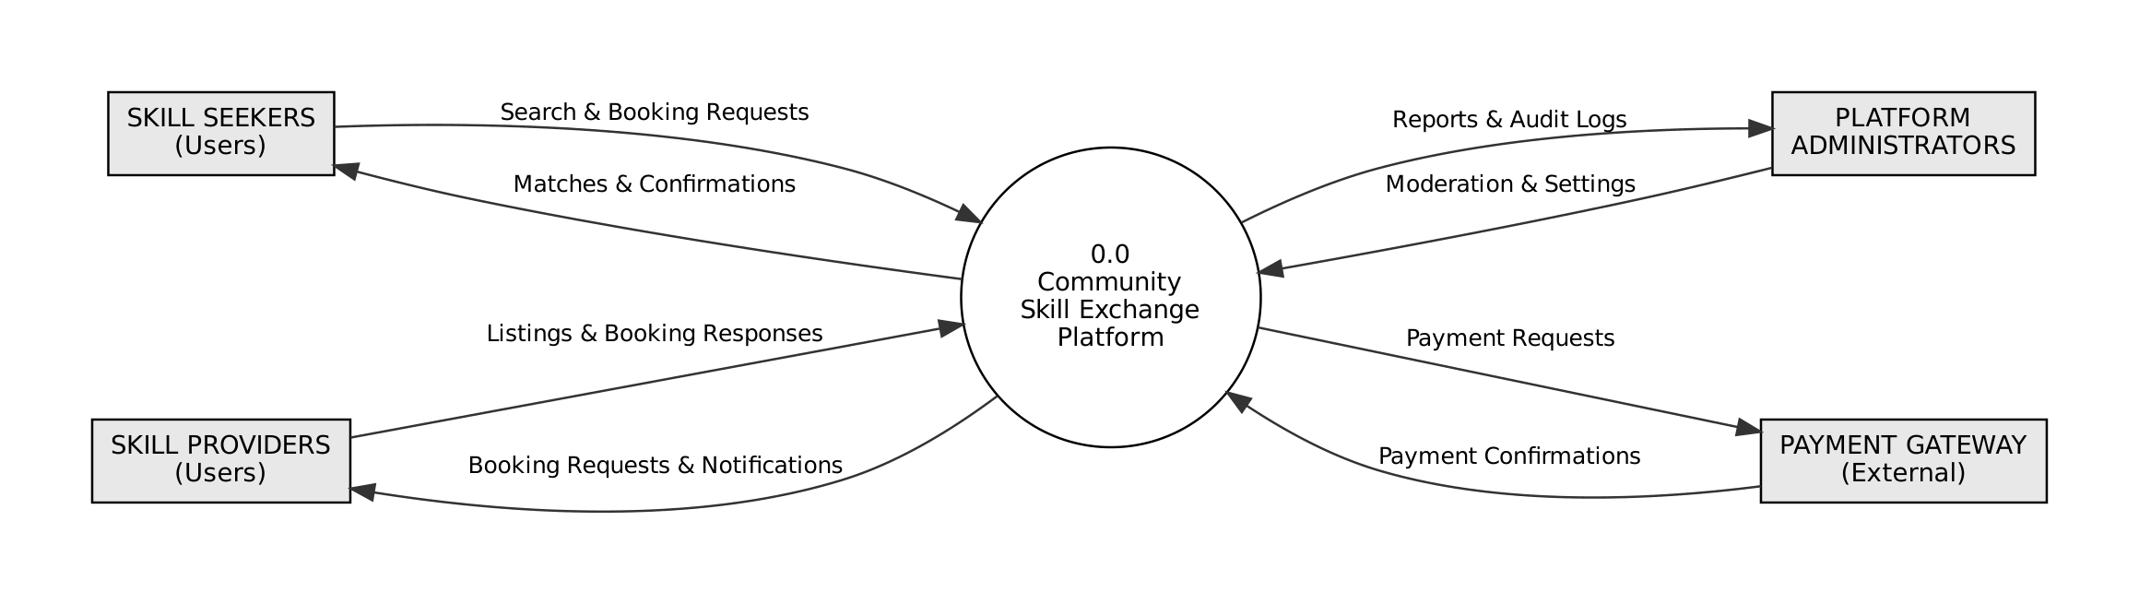
Output 2: Level 1 DFD
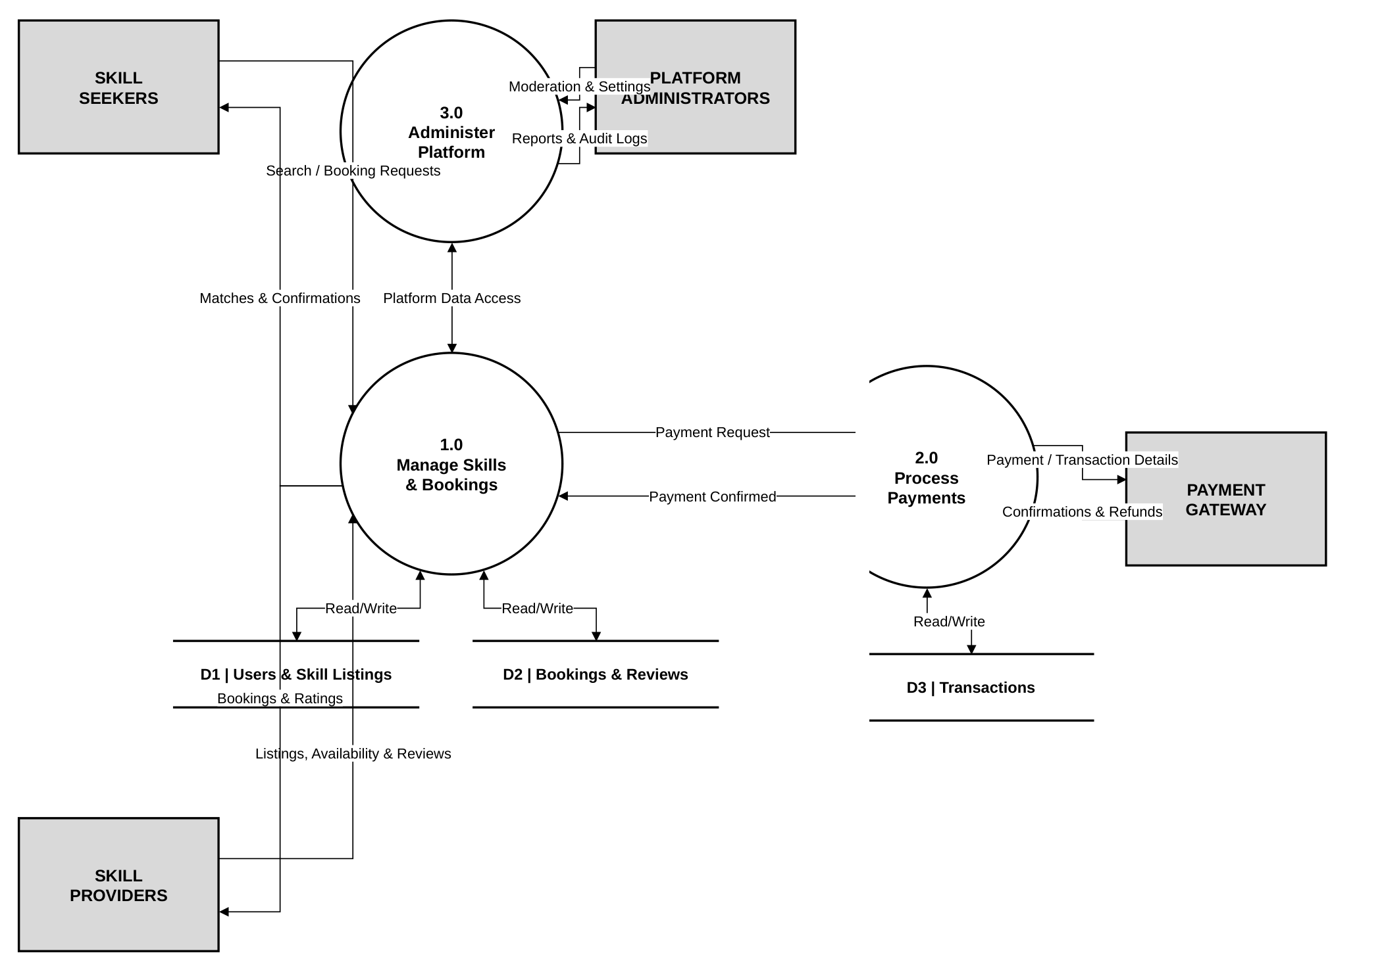
Output 3: Level 2 DFD – Manage Skills & Bookings
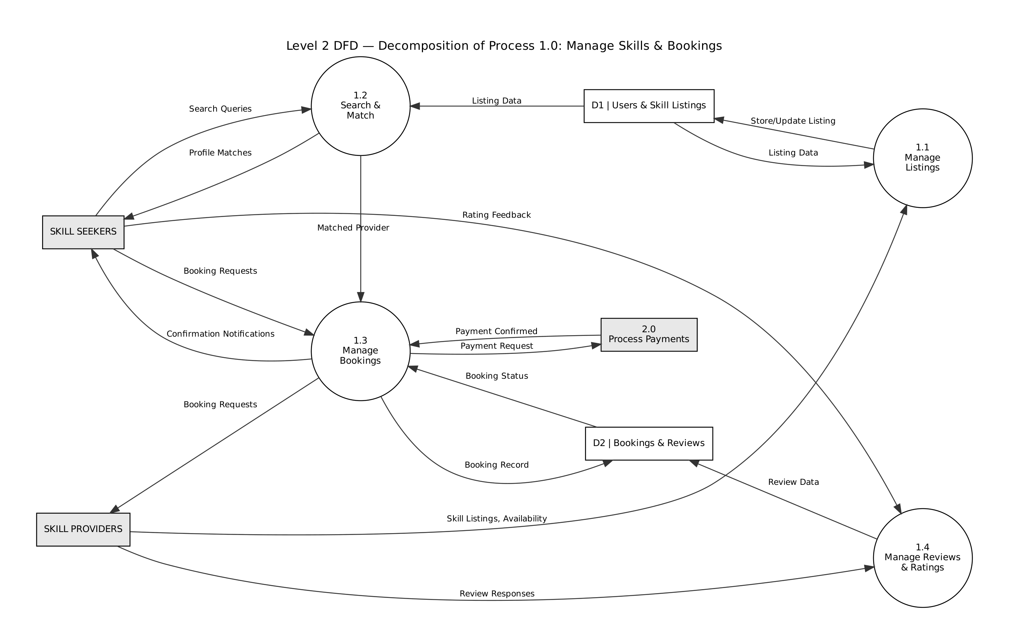
Output 4: Level 2 DFD – Administer Platform
